***End Turkey’s Campaign of Gendered Violence***

***STOP FEMICIDE IN TURKEY***

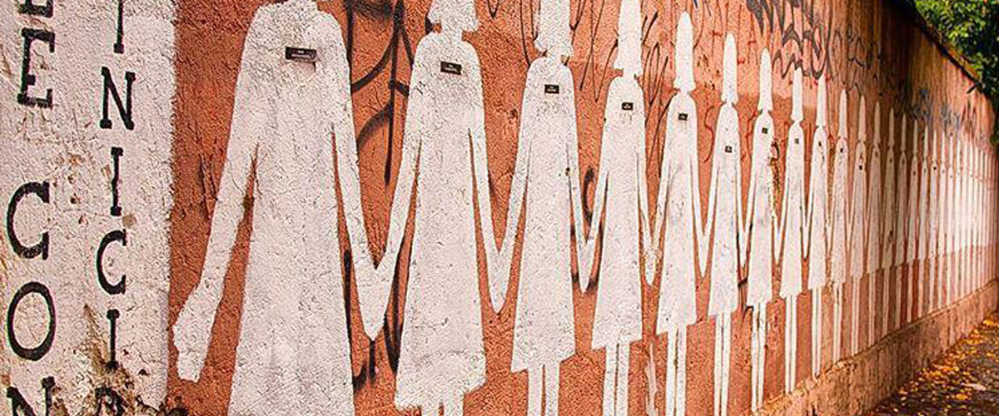

*The American Kurdish Association, Metropolitan Anarchist Coordinating Council, and Emergency Committee for Rojava are demonstrating in front of the Turkish Consulate General on October 13th in support of the women and queers victimized by an increasing atmosphere of violence against women. We also stand against the withdrawal of Turkey from the Istanbul Convention's binding agreement to end gender-based violence. We protest the rise in violence against women globally and the increasing authoritarianism of the Turkish government towards its neighbors and the Kurdish movement domestically and abroad, which is linked directly to gendered repression and femicide.*

**Here are the facts from Turkey.**

**Gendered Violence is widespread in Turkey:**

* Violence against women is deeply rooted and a prevalent issue in Turkey. According to a 2009 study, 42% of Turkish women aged between 15–60 had suffered some physical or sexual violence by their husbands or partners. Every year, the problem is getting worse: in 2019, 474 women were murdered, mostly by partners and relatives, the highest rate in a decade in which the numbers have increased year on year. The rate of violence has only increased during the COVID lockdown.

**Misogynist and Homophobic opposition to reforms:**

* Erdogan’s ruling party, the AKP, has largely ignored the issue, allowing men accused of gendered violence to go free if they claim to be religious or acting out of passion or even if they dress well in court. They have changed the law to enable children to get married, to make plans on how to pardon sexual predators, and to try to prevent divorces even if there is domestic violence
* This Istanbul convention establishes protections for women and queers. The Istanbul Convention is an internationally binding agreement to combat domestic violence and gender-based crime, including sexual harassment, psychological violence, stalking, physical violence, sexual violence (including rape), all non-consensual acts of a sexual nature with a person, forced marriage, female genital mutilation, forced abortion, and forced sterilisation, and honor crimes. Furthermore, signatories are required to avoid any discrimination based on someone’s gender or sexual identity and must include teaching material on non-stereotypical gender roles.

**Erasure of Kurdish women identity and Femicide in Turkey:**

* Pinar Gultekin is a Kurdish woman from Bitlis in Northern Kurdistan (Bakur) in the country of Turkey. She is not a Turkish woman and it is essential that this is recognized by Turkish feminists and the mainstream nationalist media of Turkey which tends to erase the identity of Kurdish women in their actions against violence against the women of Turkey. There was another Kurdish woman #FatmaAltinmakas who was murdered around the same time, a mother of six who was 7-months pregnant. She was killed by her husband after speaking out against her repeated rape by her brother-in-law in Mus province of Kurdistan. However, her story was not featured as the much as Pinar's because she was clearly, culturally, a Kurdish woman whereas Pinar was initially being portrayed as a modern Western Turkish woman for the Turkish feminist masses to rally around. In fact, it recently has come to light that because Fatma didn't speak Turkish and only spoke Kurdish her statement to the Turkish police was dismissed and may ultimately have led to her honour killing by her husband.
* This whole episode of the erasure and stigmatizing of Kurdish women brings into question the racial violence that constitutes the Kurdish woman’s subjectivities and communities locally and globally. This conversation must include the armed Kurdish women’s groups which have been met with harsh state violence, using a gross combination of racism and sexism, centered around sexualized torture, systematic rape, and propaganda that portray these militant women as prostitutes, because they dared to pose themselves as enemies of patriarchal armies. This exposes the Turkish state’s gross use of guerrilla women’s dead bodies as sites of necropolititcs against Kurdish feminist solidarity and resistance to colonialism and sovereignty. Sadly these brutally sexually slain Kurdish women over the decades have not been afforded the same luxury of having hundreds of thousands of women in Turkey and around the world joining a black/white IG women "empowerment" campaign #jinjîyanazadî

**Recent violence:**

* There has been a marked increase in violence against women since Erdogan’s threat to leave the Convention. The remains of a student, Pınar Gültekin, were discovered in the woods, beaten and strangled to death by her former partner, and then burned and tossed in the garbage. Over a dozen more femicides occurred in the weeks after her murder
* The AKP has expressed their opposition to the Instanbul convention in homophobic and misogynistic terms.
* Earlier this year, Turkish President Recep Tayyip Erdoğan said that the way to stop violence against women is to strengthen the institution of the family. AKP deputy chair Numan Kurtulmuş claimed that the Istanbul convention was “very wrong” and “played into the hands of LGBT and marginal elements” in Turkish society.
* Critics of the Convention claim that the legal and social empowerment of women will threaten the moral integrity of families and will encourage homosexuality.

**An International Issue:**

* Turkey’s threat to withdraw from the Convention is part of an international effort to restore patriarchal authority and patriarchal violence against women and queers. In Poland, lawmakers similarly indicated their intention to leave the treaty, citing its requirements to teach children about gender and its “ideological nature.” The issue is also being debated in Croatia and Serbia.

First, thank you, my friends, for your valuable sensitivity. I'm trying to convey to you as much as I can our problems these days.

A woman is in Turkey in the case of a subject who is kept in the background under various pretexts.In case of the "one-man hierarchy"far from freedom, women are again the most affected compared to men. At home, at work, on the street...we are oppressed, despised. In order for us to be equal to the men we do the same job with and get the same salary, we need to overturn 110 years in statistical terms. For male morality, subjects that are observed and sensitive as intimate become rude when it comes to a woman; labels and accusations always reach a functional dimension over a woman. When it comes to the concept of honor, only women come to mind, and practices are shaped against women and other oppressed masses. In society, a declared gender is expected in all areas, and non-binary people are included according to anatomical body characteristics in all cases in society, queer people are stigmatized according to their anatomical body. The traditional exploitation rules which is designed for women, also applies to queer people. Trans women are put in men's wards in prisons, raped, burned to death because they have the courage to perform themselves. Traditional methods imposes on women to stand in the background next to men, neither in front of them nor on their sides and to walk behind them, to take charge of household chores and intimate rooms. Women's only free choice is that they can make the choice of the man they will marry-there are many exceptional cases - so they can make their social status(!) they are crushed under that situations and cannot breathe. Female and queer persons, as well as persons with anatomical male bodies, are objectified and seen as if their bodies are suitable for harassment and rape; they are not protected under any law. The oppressed segment of society-women,queers, trans people...- their moral questioning is in the hands of men and the patriarchal state. Right now, oppressed women and queer individuals are despairing. It is impossible to destroy this despair without destroying state institutions. There's no punishment for killing women.Where, if any? The dysfunctionality of the voting parties and legislatures is one of the reasons it has to be destroyed. And our rights doesn't have to be saved, our sisters will avenge us. As women become conscious and self-confident individuals, the problems I'm talking about now will disappear, because as Virginia Woolf said: We're like babies in a cradle without self-confidence. As passive as they are, we'll stay that way as long as we hope to vote. Masculine individuals who commit crimes against humanity are exonerated by taking advantage of their socially inflated opportunities and continue their lives in their usual form without being excluded in any sense. And we would rather destroy and set fire to it than see that the police, politicians, various members of the bourgeoisie are favored in the newspaper pages and in the news every day, and that the masculine mentality is recommended, so that the fire in our hearts cools a little. There will be no law that will give us our right, freedom will not distributed, it have to taken; in anger, by blood. Yes, 6284; it is abolished by the one-man administration using all kinds of manipulative ways, and the action ranks that we are fighting for otherwise are eliminated by all kinds of torture ways. But we'd rather plunder members of the masculine mindset, than believe that something will change through the law. In the geography of Turkey, on International Women's day, you can see that women's body and others were beaten, humiliated, raped by police, and the cause of all kinds of crimes committed against them is attributed to their clothing. Here we are in Turkey, and we cannot promise that the bright days will come, but the day will come when women will see their freedom taken away, and the Patriarchy, the state that prevents it, will be destroyed. This is our war, and we will not stop.

If you are not punished by a ban on entry to Turkey after the action to be taken, and if you end up in Turkey, I would be honored to welcome you to a commune where there is no betrayal. Peace be upon those who bear the fire of freedom in their hearts.

Kali Yuga

Kali Yuga

sent

2 days ago

I think it's a big problem that the birth of a boy is still considered as flattering, and woman who hasn't given birth is as seen as lack that considered a big problem.

One of the major points of criticism is that the Convention does define the term \u201cgender\u201d as \u201cthe socially constructed roles, behaviours, activities, and attributes that a given society considers appropriate for women and men\u201d. \n\nSome countries considered this definition as too broad and feared it could be interpreted to make way for the allowance of a third gender. However, according to the Convention gender and sex are two separate concepts and the definition does not intend to replace the terms for \u0022women\u0022 and \u0022men\u0022. \n\nThere is no explicit mention of the terms \u0022intersex\u0022 and \u0022transgender\u0022 within the Istanbul Convention. The parties are, however, required to avoid any discrimination based on someone\u2019s gender or sexual identity, as well as their race, colour, language, religion, political or other opinions, national or social origin, association with a national minority, property, birth, age, state of health, disability, marital status, migrant or refugee status. \n\nAnother aspect some countries are hesitant to oblige by is that the Istanbul Convention requires parties to include teaching material on non-stereotyped gender roles. This is on occasion regarded as an attempt to enforce a liberal, western lifestyle in more traditional and conservative societies - as they perceive themselves. \n\nDoes the Istanbul Convention have an actual impact? \n\nAccording to the Parliamentary Assembly of the European Council (PACE),